DIAGNOSIS OF COVID19 SYMPTOMS IN X-RAY IMAGE WITH RadioAI

**The issue**

Since the lockdown due to corona virus, the testing of contacted patients is quite difficult as there is limited testing not only from the government but also from private care institutions. Generally, RT-PCR is the gold standard method for testing but its accuracy is around 70% and due to this many clinicians and researchers suggested that if any patient is symptomatic they can undergo X-ray chest or CT-chest for mere identification of corona symptoms in it which gives accuracy of almost to 90%.

While nowadays many of the clinicians are advising for chest x-ray and CT- chest scans the reporting of the scans is taking too long and TAT of the report is getting delayed by at least 2-3days as due to shortage of radiologists. (Ref- some recent studies regarding delay reporting) And in this pandemic many of the patients want to know whether they are prone to covid19 or not so that they may not be the carrier for others.

The delay in reporting by radiologist and giving results faster to the patient which motivated me to find a solution for this problem.

**Our Magic solution**

Since we are trying to solve delay in reporting by radiologist and giving faster results to the patients, we have identified a unique solution to the underlying cause

**To develop an AI model which assist the radiologist in identifying x-ray abnormalities**

Our solution is to develop an AI based assisted application while doing x-ray reporting by radiologist the application would detect few abnormalities which helps the radiologist to report faster and also helps not to miss out of any feature in x-ray.

**How it works**

**Step 1 :** **Data collection & Pre processing**

Collected the dataset of x-ray images of both normal and abnormal from a diagnostic Centre. Around 300 images were collected. Ground truth is marked by the radiologist wherever they see abnormality.

x-ray images are taken and ground truth is marked by the radiologist wherever they see abnormality

The sample image is given below

1020123537_35.jpg

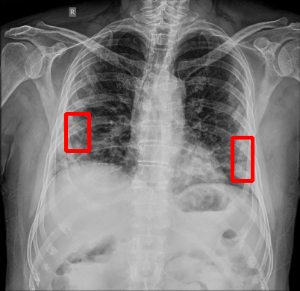

For each image the ground truth abnormality region is marked and Annatoate.CSV is created like below in the table.

Table of Ground truth labeled by the Radiolist.

|  |  |  |  |  |  |
| --- | --- | --- | --- | --- | --- |
| **Image Name** | **AbNormal Type** | **xmin** | **ymin** | **xmax** | **ymax** |
| person11_virus_38.jpeg | Pneumonia | 437 | 599 | 576 | 760 |
| person17_virus_48.jpeg | Pneumonia | 352 | 179 | 455 | 334 |
| 30205873_10.jpg | Pneumonia | 89 | 211 | 216 | 359 |
| 30205873_10.jpg | Pneumonia | 371 | 225 | 452 | 271 |
| 72204356_36.jpg | Pneumonia | 338 | 111 | 392 | 153 |
| 72204356_36.jpg | Pneumonia | 108 | 145 | 141 | 181 |
| 142026264_50.jpg | Pneumonia | 151 | 147 | 187 | 205 |
| 432034657_55.jpg | Pneumonia | 300 | 150 | 327 | 174 |
| 432035567_61.jpg | Pneumonia | 120 | 186 | 143 | 220 |
| 1020123537_35.jpg | Pneumonia | 311 | 186 | 338 | 244 |
| 1020123537_35.jpg | Pneumonia | 88 | 154 | 119 | 204 |
| 1020124683_38.jpg | Pneumonia | 111 | 64 | 144 | 105 |
| person8_virus_28.jpeg | Pneumonia | 584 | 139 | 673 | 255 |

The Annatoate.csv file is processed as text file suitable for the training. Annotate.txt

train_images/person11_virus_38.jpeg,437,599,576,760,Pneumonia

train_images/person17_virus_48.jpeg,352,179,455,334,Pneumonia

train_images/30205873_10.jpg,89,211,216,359,Pneumonia

train_images/30205873_10.jpg,371,225,452,271,Pneumonia

train_images/72204356_36.jpg,338,111,392,153,Pneumonia

train_images/72204356_36.jpg,108,145,141,181,Pneumonia

train_images/142026264_50.jpg,151,147,187,205,Pneumonia

train_images/432034657_55.jpg,300,150,327,174,Pneumonia

train_images/432035567_61.jpg,120,186,143,220,Pneumonia

train_images/1020123537_35.jpg,311,186,338,244,Pneumonia

train_images/1020123537_35.jpg,88,154,119,204,Pneumonia

train_images/1020124683_38.jpg,111,64,144,105,Pneumonia

train_images/person8_virus_28.jpeg,584,139,673,255,Pneumonia

**Step 2: Training & Model creation**

Faster- RCNN algorithm is used to train the x-ray images along with annotate.txt file.

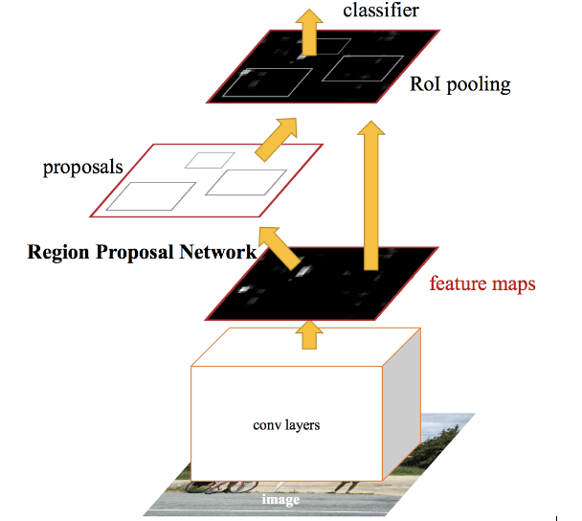

The model is trained to detect the single label of the Pneumonia in the x-ray images.

Keras-frcnn library is used for the training

python train_frcnn.py -o simple -p annotate.txt

Around 500 epochs of training gave good results.

Model is tested with trained images and some new images as well.

Tested the 1020123537_35.jpg with model. It is able to detect the abnormality. Green Rectangle in below image in detected Abnormality

1020123537_35.jpg test results

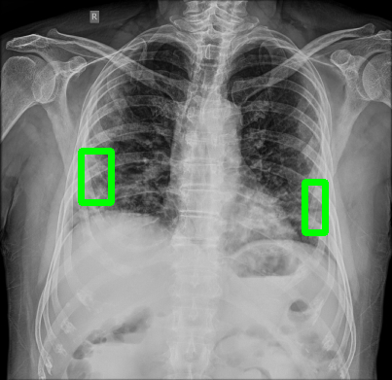

**Step 3 : Building User Interface & testing**

User Interface is created with react JS to accept the x-ray images from the user for testing. It calls the backend model for detection. it shows the result with abnormality green rectangle.

Result from the model:

{0: 'Pneumonia', 1: 'bg'}

Loading weights from ./model_frcnn.hdf5

1020123537_35.jpg

Elapsed time = 16.021418809890747

[('Pneumonia', 99.9940037727356), ('Pneumonia', 99.76078271865845)]

The result from the mode is processed and displayed in the UI.

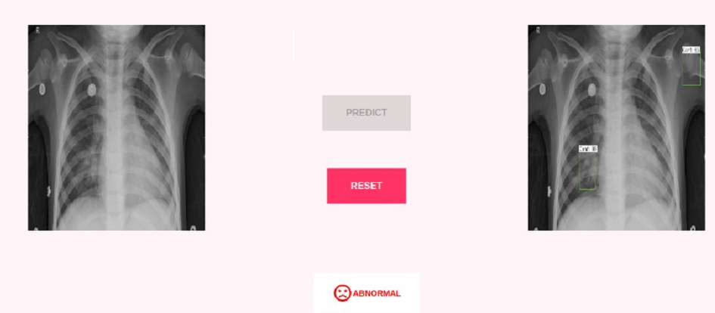

Result

Input image

Action button to invoke the model

Output image

**Step 4: Evaluation & Radiologist feedback and way forward**

Detects @ 99%confidence level for >75% test images. Speed is <5sec in i5 processor.

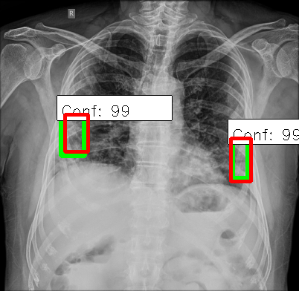

Confidence of detection

Green Color Rectangle is detection

Red Color Rectangle is Ground truth

We have taken the radiologist feedback in two ways to test our model-

1st way is- we have taken already identified abnormal images and made markings on the x-ray with radiologists and later we tested the model where the model predicted with 80% accuracy

2nd way is- We have trained few models based on some of the radiological findings and tested few images which are right undergoing with radiologists remarks on the tested images.

Model to be trained with additional abnormal images to further improve accuracy.